Unit 1 Miêu tả người

1. Chỉ có một người

* ♦ Quan sát hành động, trạng thái của của nhân vật (họ đang làm gì, mặc trang phục như thế nào…)
* ♦ Quan sát địa điểm của tranh ( bức tranh này diễn ra ở đâu? ở nhà hàng, bệnh viện hay sân bay…)
* ♦ Tập trung vào hành động tổng quát
* ♦ Tóm lại đối với tranh có 1 người chỉ cần tập trung vào động từ, giới từ và các túc từ ( đi sau động từ , chịu tác động của động từ đó)

|  |  |
| --- | --- |
| Seeing | Examining the engine  Checking her watch  Checking her reflection in the mirror  Looking through the window  Gazing at the scenery  Staring up at the mountain |
| Writing | Writing in some paper  Writing something down  Talking note |
| Eating and drinking | Eating a meal  Drinking from a cup |
| handing | Holding a tool  Moving the cartons  Handing a letter  Carrying some chairs |
| Working | Doing two things at once  Making a copy |
| Telephoning | Talking to someone  Hanging up  Making a call |
| Wearing | Wearing a shirt  Taking off his sweater  Putting on his shoes  Adjusting her glasses  Trying on some clothes |
| Acting | Resting the bag on her lap  Holding onto the railing  Folding his arms  Has gloves on  Removing her headset  Learning toward the display |

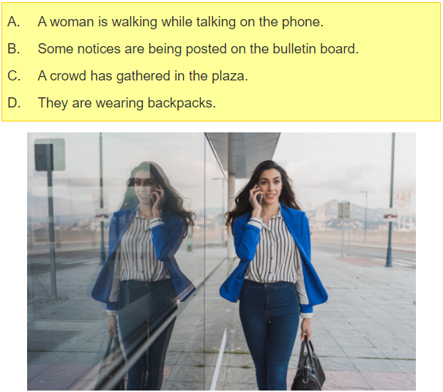

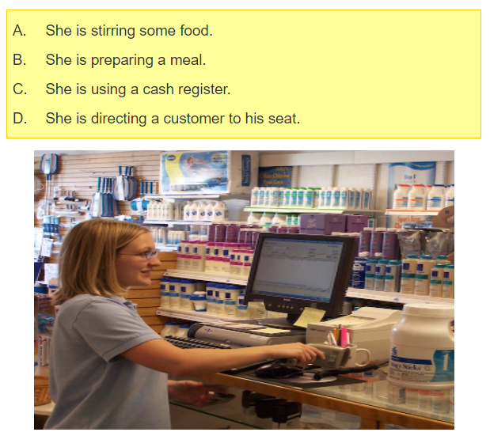

1. Một người với 1 vật

Chú ý các hành đồng tác động lên vật ở thì hiện tại tiếp diễn bị động

|  |  |
| --- | --- |
| Actions | Being put away  Being down  Being weighed |
| Locations and states of objects | Be piled up  Hanging from the ceiling  Be located against the wall  Be filled with books |

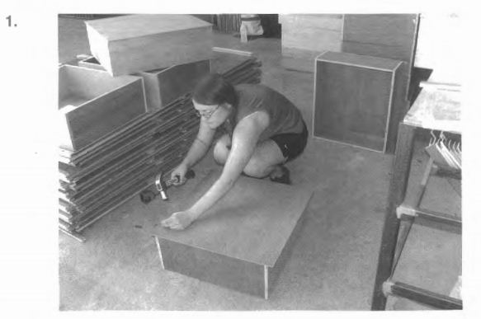

**Exercise 1:**

1.

1. She is cutting a piece of wood.
2. She is constructing an outdoor wall.
3. She is focusing on hammering a nail.
4. She is fixing the power cable.

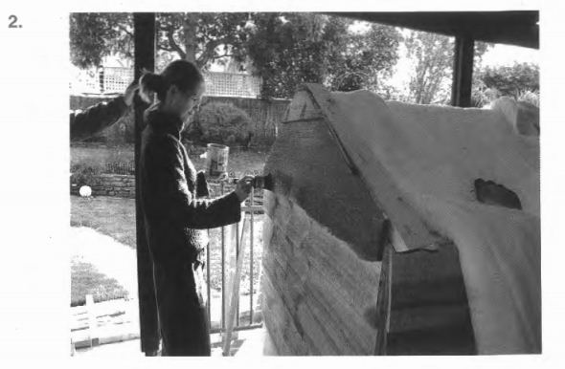

2.

(A) She is turning a knob.

(B) She is painting the wall of the park.

(C) She is using a brush.

(D) She is painting a roof.

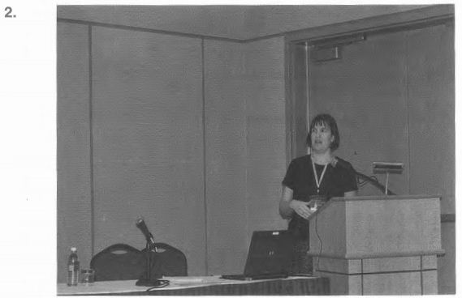

(A) The woman is gesturing with her hands.

(B) The woman is being interviewed.

(C) The microscope is being repaired.

(D) The laptop computer has been placed on the table.

3. Tranh có 2 người trở lên

♦ Quan sát những điểm tương đồng của các nhân vật ( in the office, at the meeting)

 ♦ Quan sát sự khác biệt giữa các nhân vật ( one woman is standing, people are sitting…)

 ♦ Quan sát mối quan hệ giữa các nhân vật ( they’re colleagues)

 ♦ Vị trí của người và vật trong hình

|  |  |
| --- | --- |
| Getting together | Be assembled for  Having a meeting |
| Greeting/Talking | Chatting each other  Having a dicussion  Addressing one’s colleague  Greeting each other  Be interviewed  Shaking hands |
| Current states | Be lined up  Side by side  Next to  Sitting across from each other  Facing each other |

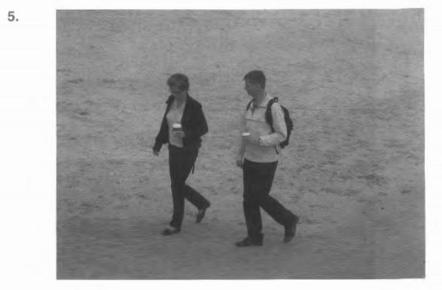

(A) There is alone walker on the beach.

(B) The couple has just walked past the cafe.

(C) They are walking side by side.

(D) They are holding onto a basket.

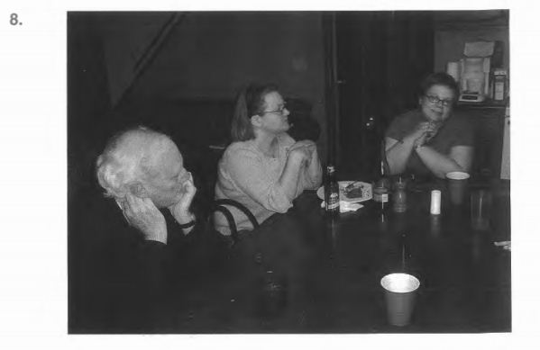

8.

(A) They are having a discussion in a classroom.

(B) A man is resting his chin on his hand.

(C) Most of the seats are unoccupied.

(D) Some people are bending over the table.

4. tranh có nhiều hơn hai người với vật

Tập chung vào hành động chung và tình hình chung của tranh

|  |  |
| --- | --- |
| States and grouping | Be crowded with people  Be filled with people  Be grounded together  Chatting in small  Groups be full of people  Some people are applauding |
| Relaxing | Be shielded from the sun  Sunbathing on the  Relaxing on the lawn  Beach fishing on the shore  Walking along the pier  Waving to their friends |
| Object | Be occoupied  Be packed with  Be taken  Be arranged in rows  Be empty |

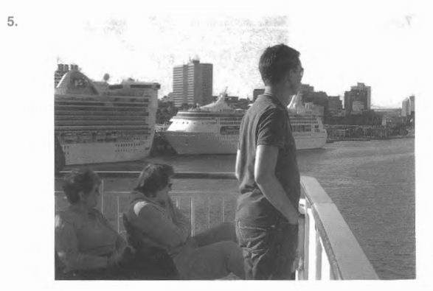

5.

1. They are sitting in a circle.
2. They are having a conversation.
3. They are wearing glasses.
4. They are gazing at the bridge

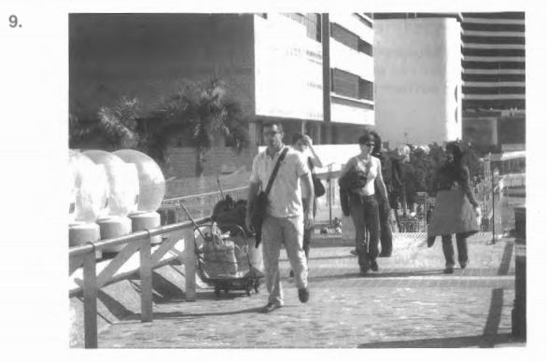

1. People are walking past the bench.
2. A man is carrying a bag.
3. The path leads down through the woods.
4. Some people are working on the road.

Task 1: Listen and fill in the blanks (file 05)

1. The woman is.. ... the street with a broom.

2. The woman is .. the girl's arm.

3. The man is…...a phone conversation at the desk.

4. The speaker is ...into the microphone.

5. He is…….on the paper with a pen.

6. She is pouring the liquid into the cup.

7.The man is…….at the computer.

8. A woman is……..something under her arm.

Task 2: Listen and fill in the blanks (file 06)

1. They are………...a document.

2. They are………… the audience

3. The musicians are ........instruments.

4. They are ……..a row

5. They are…………... from each other.

6. They are. …………………

7. Children are. . …..the water fountain

9. The travelers are. ……...their suitcases.

Task 4 (file 07)

1. One of the men is . . protective gear.

2. The woman is .. a pile of books

3. One man is ..... with an electronic device.

4. Construction workers have . ….. off the road.

5. He is …... a pen up over his head.

6. A woman is ……..the sweater on a chair.

7. Some people are……...themselves to refreshment

8. One man is ………. some photographs.

9. They are……….. .cartons in s storage area.

10. She is…………. a plate down on a table

11. The man is …….. onto the balcony.

12. The men are …………… outside the building.

13. They are ……………..in line at a ticket counter.

14. People are …………….in a group.

15. The women are………....near the water.

16. She is ………………...down the cup.

17. Both of them………….an arm around the other.

18. They are…………………..purchases in a shop.

19. The man is …………… on the beach

20. They are……………….for pedestrians to cross.

File 08

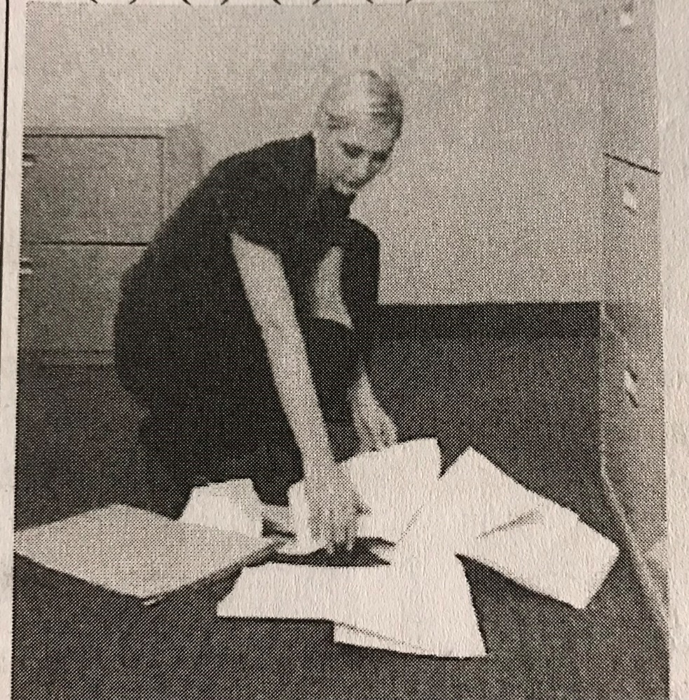

1. The woman is wearing a pantsuit
2. The woamn is picking up some documents
3. The woman is throwing some papers
4. The woman is puttingon her shoes

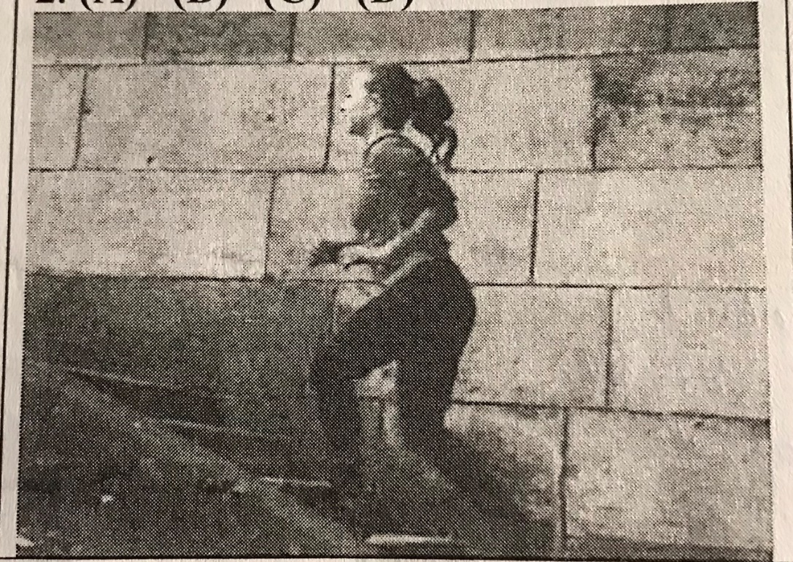

1. The Athele is going down the stairs
2. She is running up the stairs
3. The woman is working out of the gym
4. The woman is wearing a swimsuit

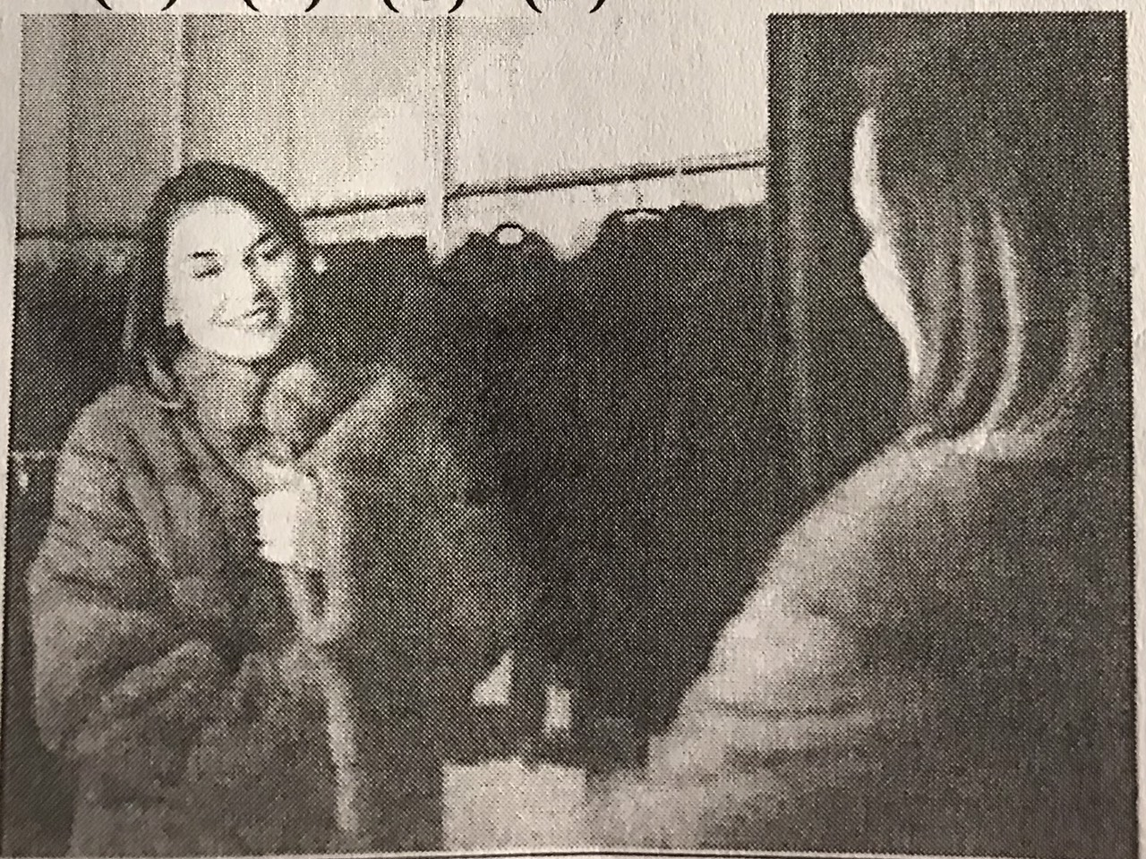

1. She is trying on a coat
2. She is buttoning of a coat
3. She is picking up some laundry
4. She is unpacking her stuff

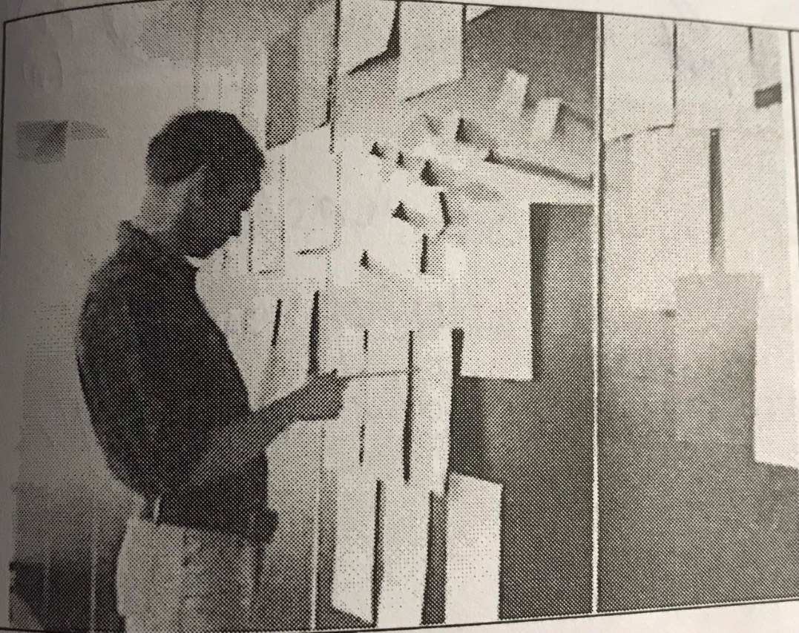

1. A man is posting up a poster
2. A man is watching a board
3. A man is drawing on the board
4. A man is collecting handout

File 09

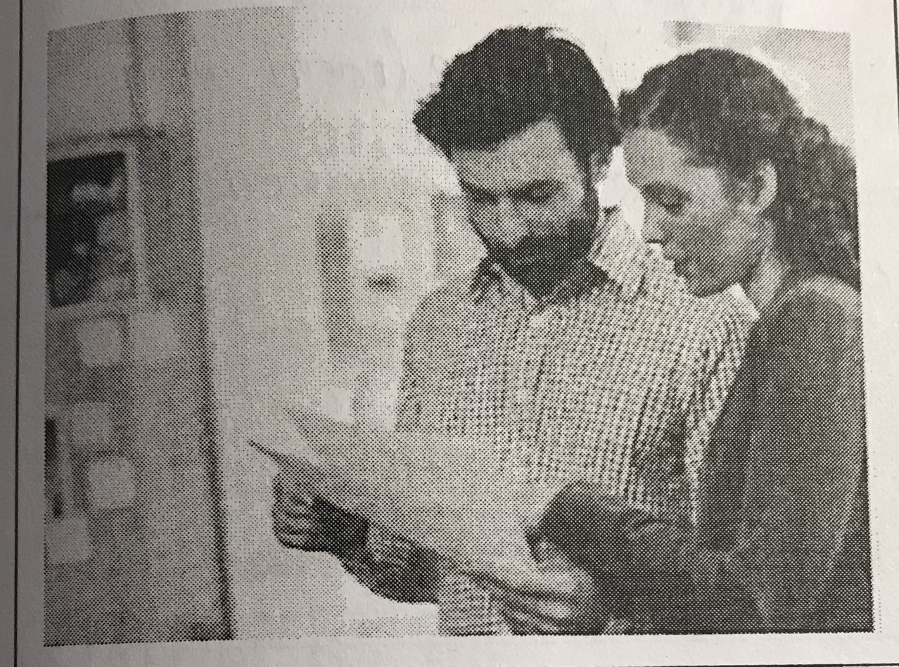

1. They are looking at the documents
2. They are handing out the documents
3. They are laughing at loud
4. They are writing up a report

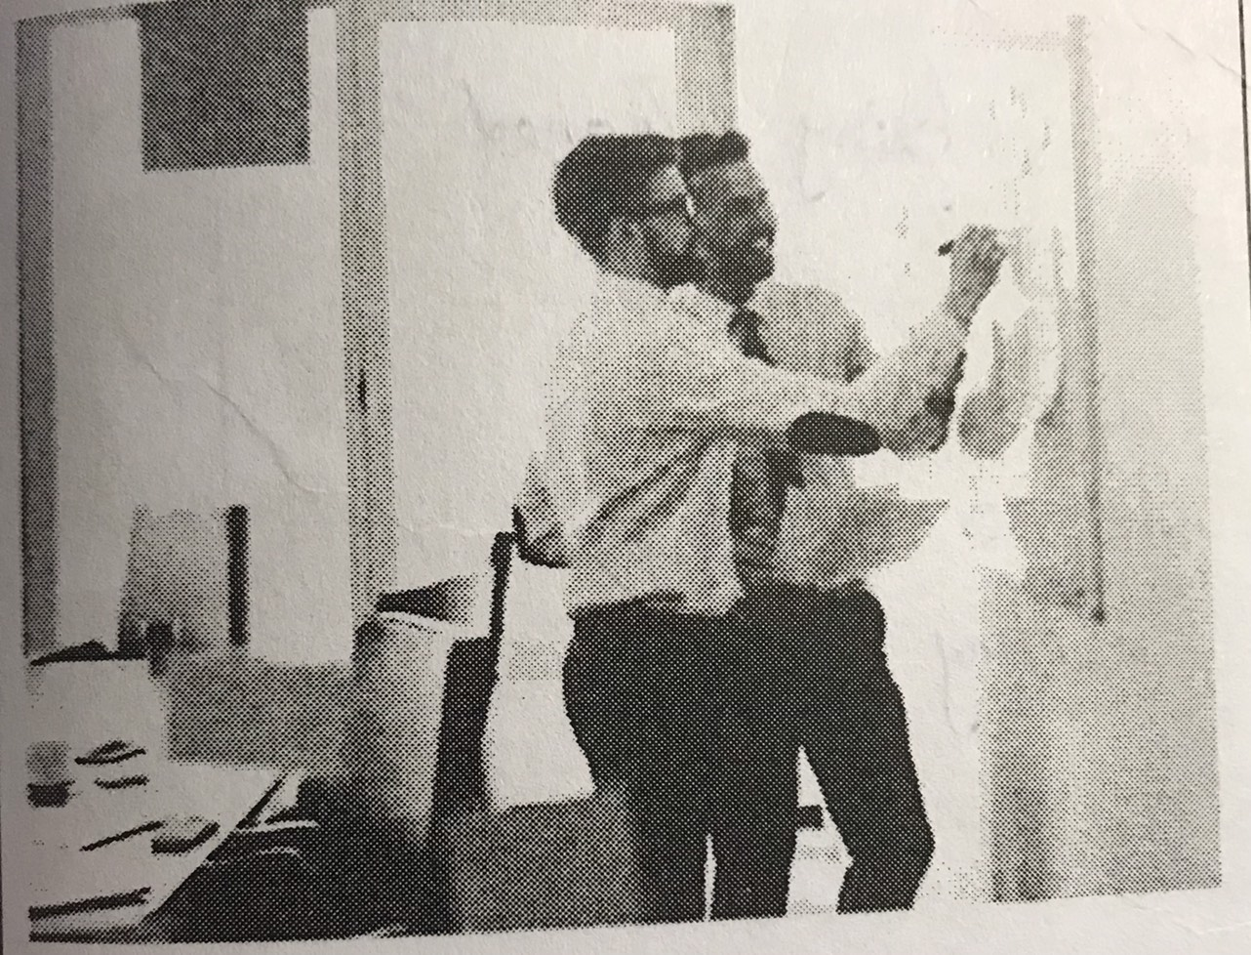

1. They are posting some poster
2. They are writing up a public notice
3. One of the man is wriiting a note on a board
4. One of the man is helping the others one

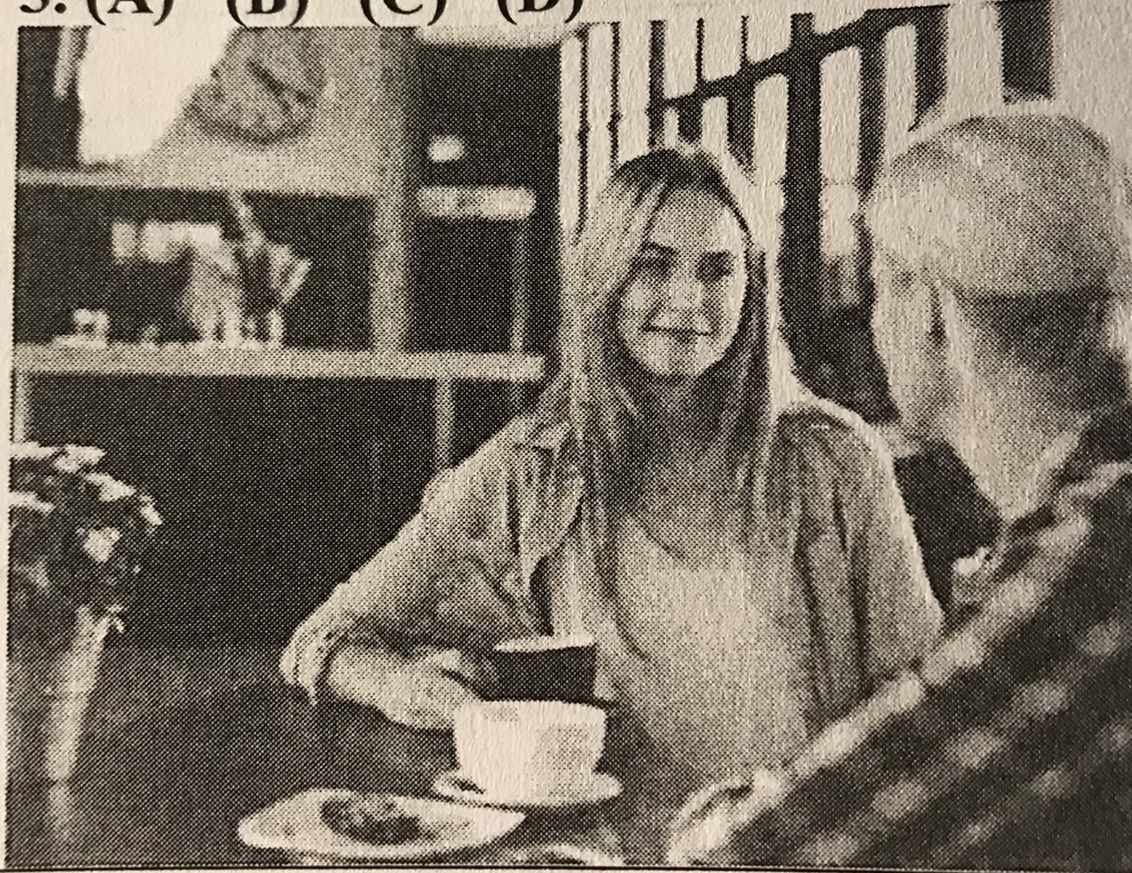

1. A flower pot has been placed on a chair
2. The coffee cup so wash
3. The women are ordering dessert
4. The women are looking at each other

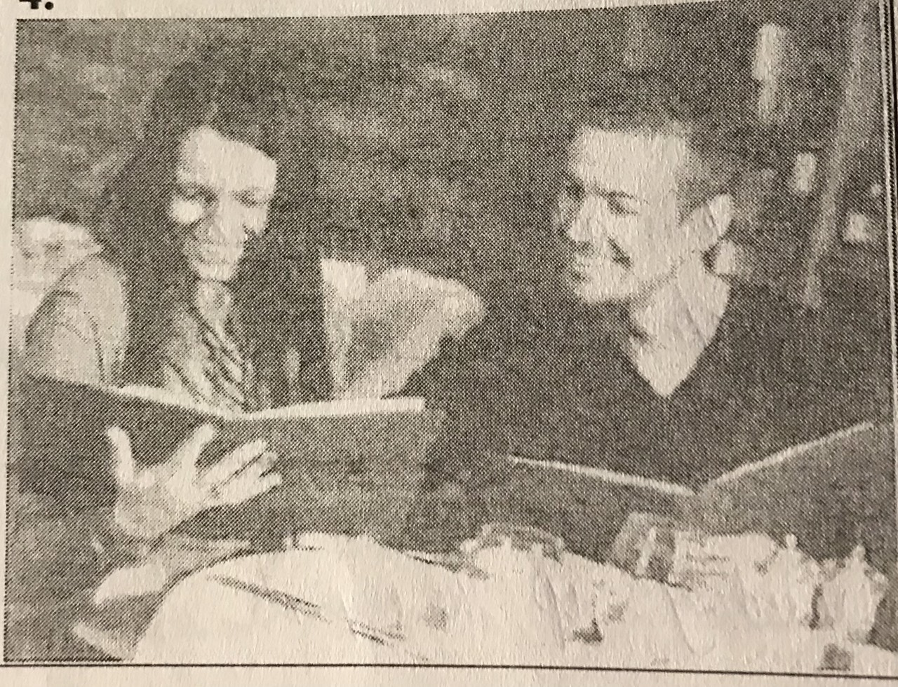

1. They are taking up some coffee
2. They are studying th menu
3. The glasses being cleared away
4. The tableware (bộ đồ ăn) has been placed on a counter

File 10

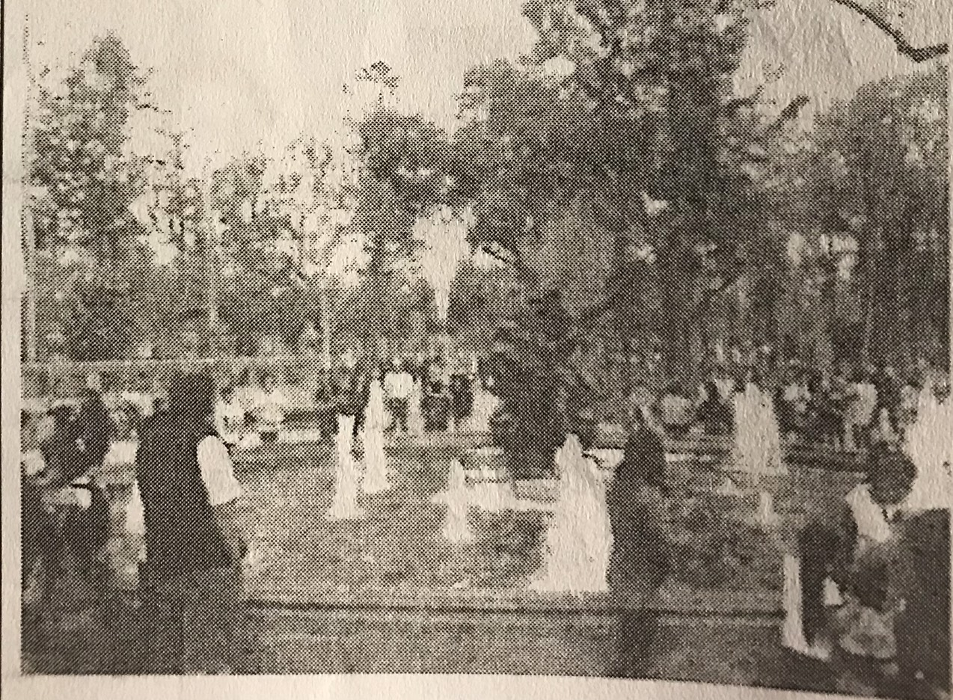

1. A fountain is being cleaned
2. People are gathered around the fountain
3. Some people are feeding birds
4. People are waiting to see the performance

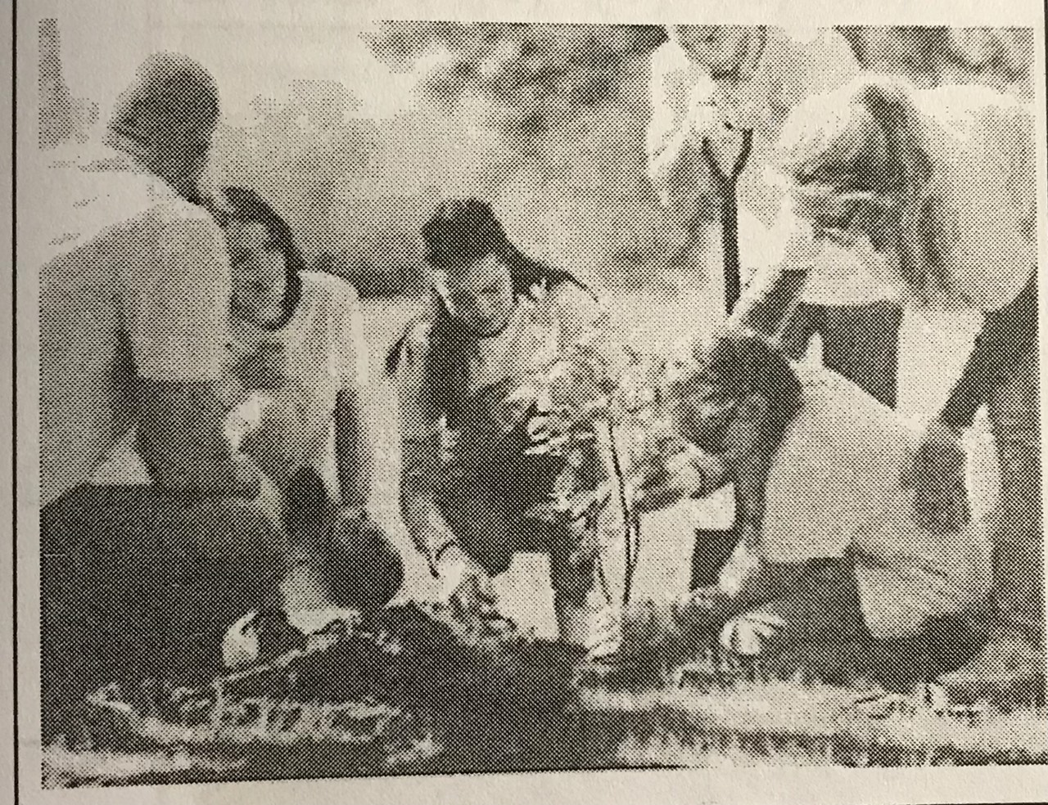

1. They are working on a farm
2. A plant is being planted
3. They are putting seed in a pot
4. They are sitting on a ground

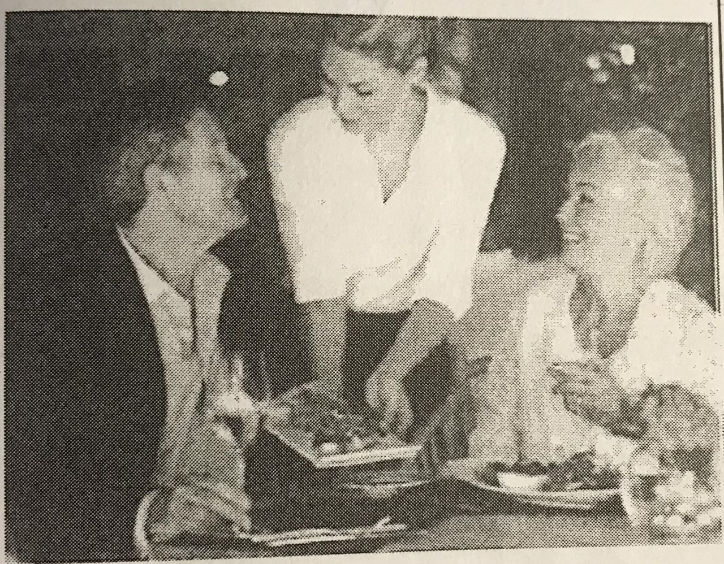

1. People are indoor restaurant
2. Food is being cleared from the table
3. Some people are enjoying their food
4. A waitress are taking an order

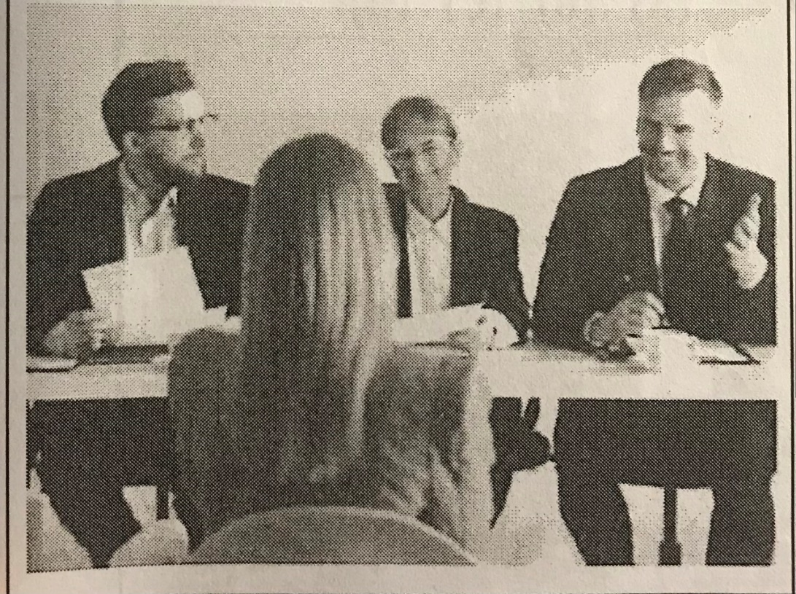

* 1. People are having a conference
  2. An interview is being conducted
  3. Some furniture is being arranged
  4. People are looking at each other

File 11

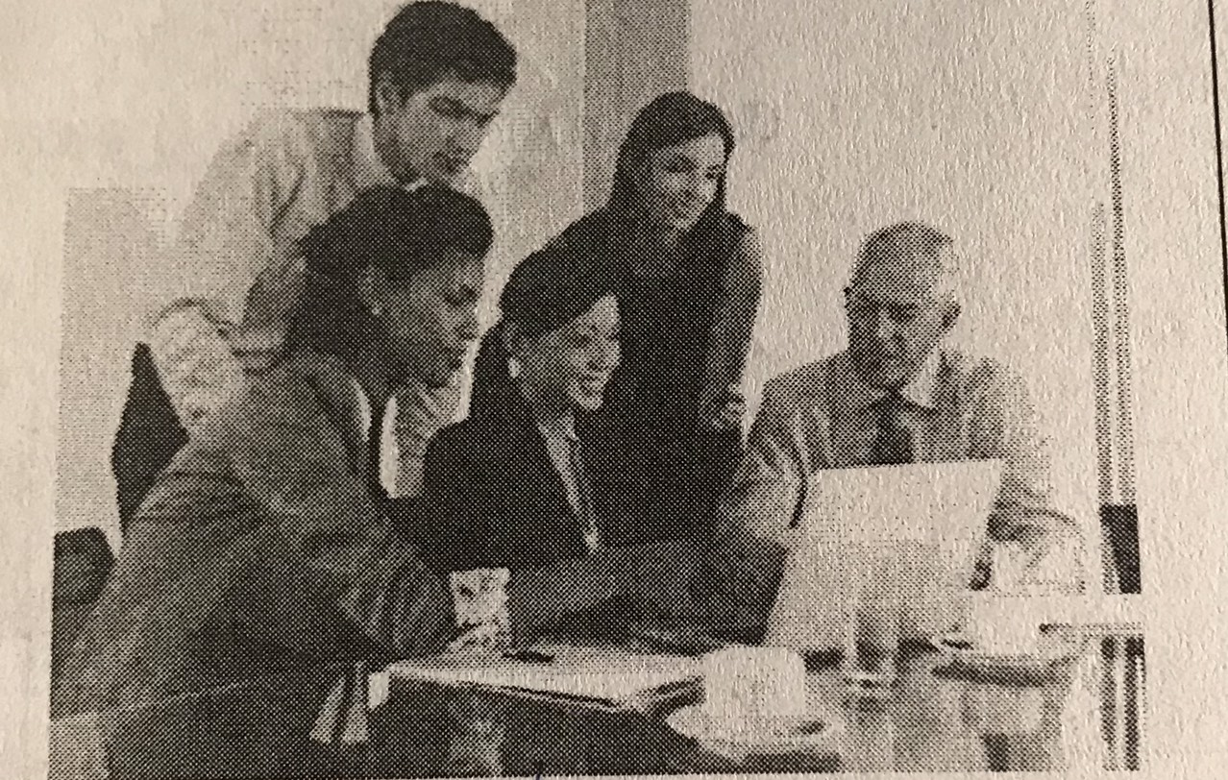

1. People are working on a project
2. A computer is being used
3. Some food has been placed on a table
4. All of them are typing on their computer

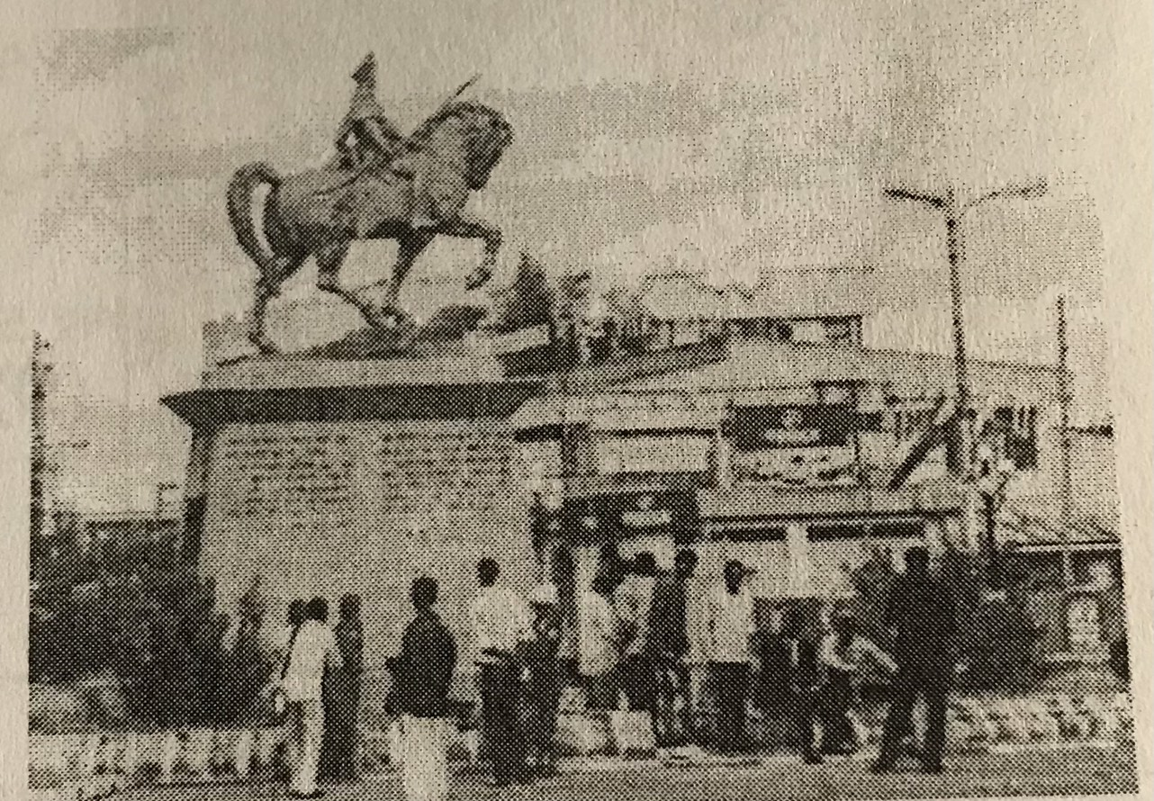

1. People are gathered around the statue
2. They are looking at the performance
3. A monument (tuong dai) is being installed
4. People are taking pictuer

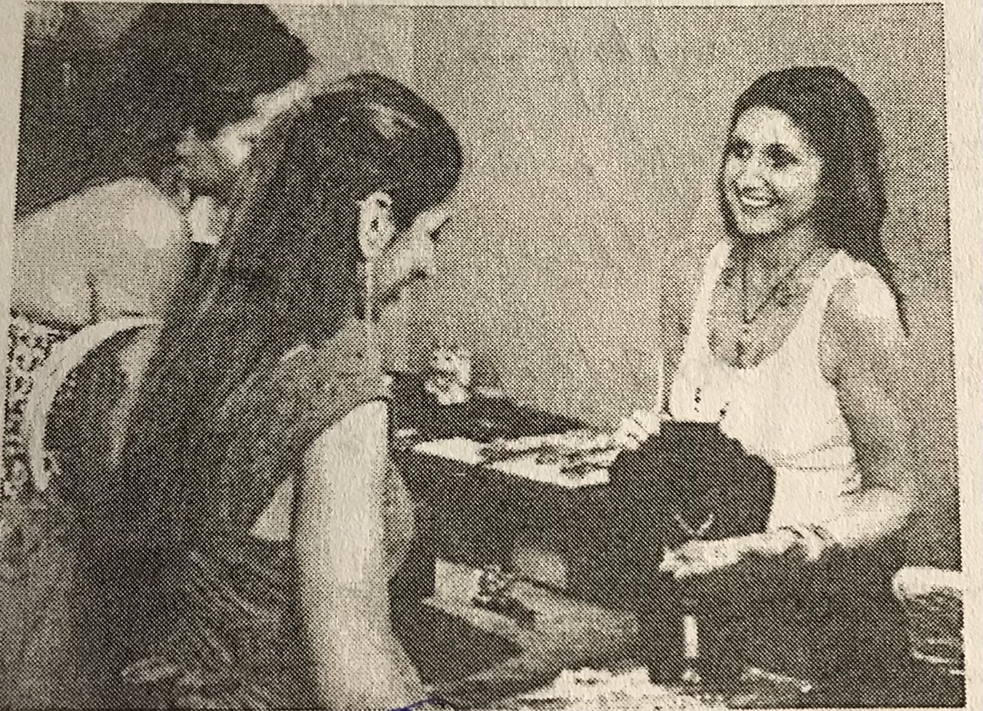

1. They are selling jewerly
2. A neckleg is being shown
3. They are looking for some rings
4. A counter is being cleared

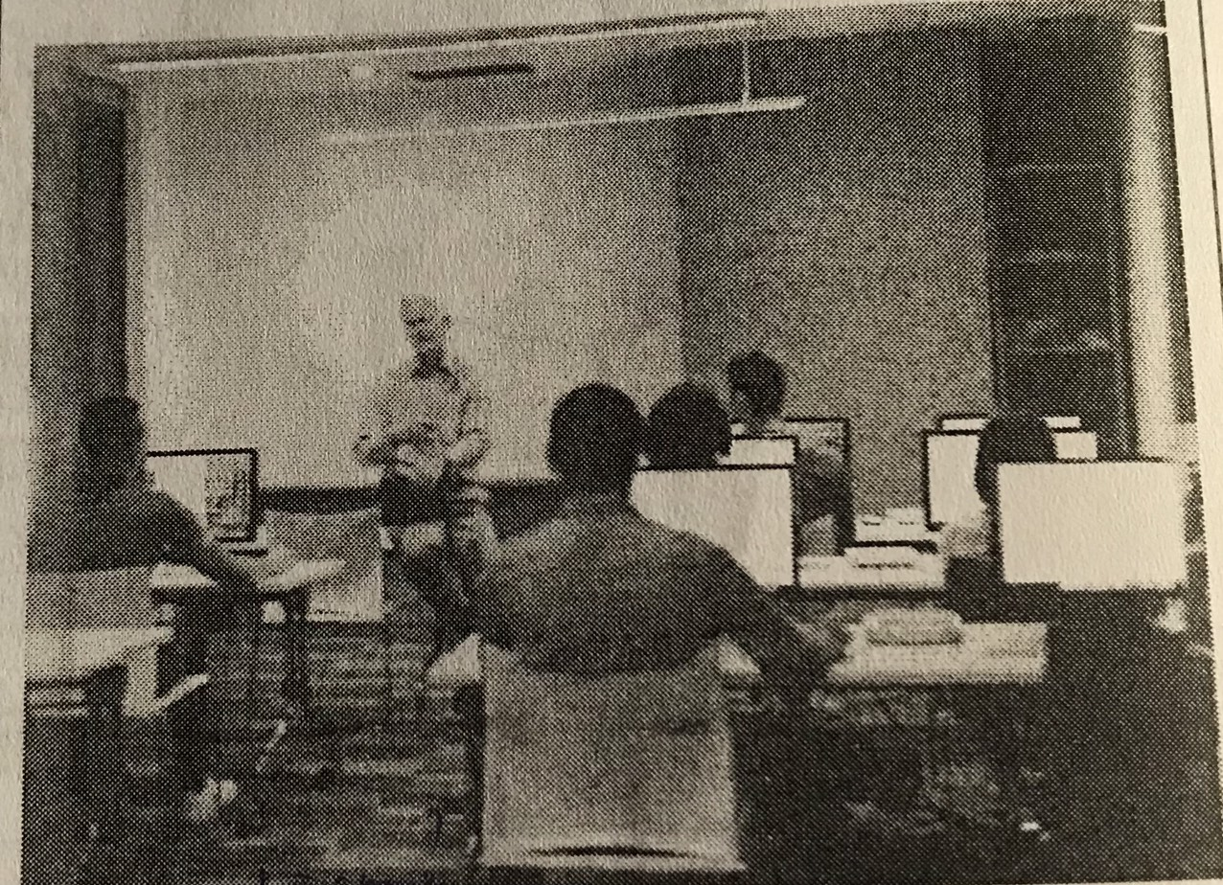

1. Students are taking note
2. People are looking at their computer
3. A lecture is being given
4. They are giving a speech

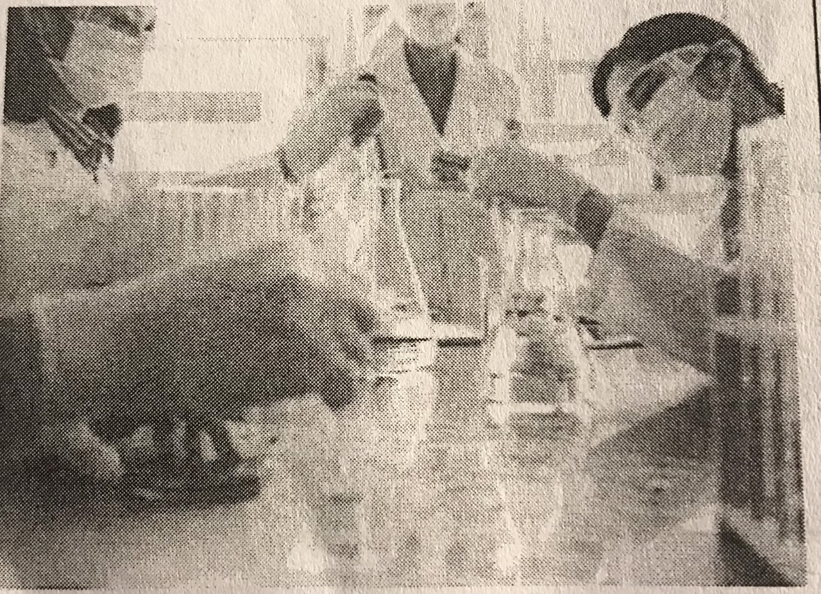

1. They are cleaning the tools
2. They are taking care of the patient ( benh nhan)
3. They are working in the lab
4. They are putting on gloves

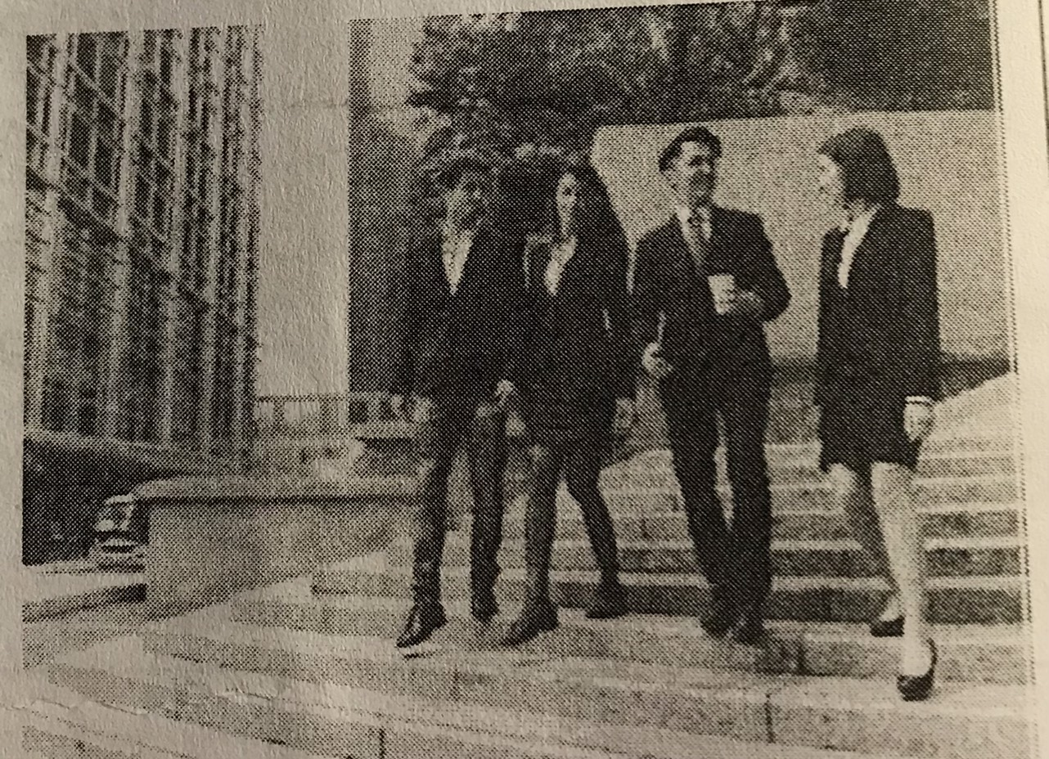

1. They are waling down the stairs
2. They are in a meeting
3. They are wearing protective clothing
4. The stairs are being cleaned

File 12 – file 17

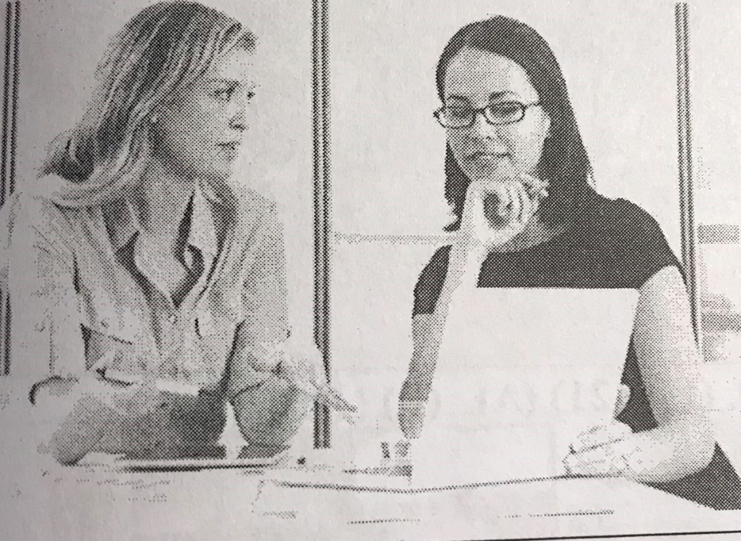

1. They are writing on a piece (mảnh )of paper
2. They are looking at each other
3. One of the woman is holding a pen
4. One of the woman is typing on a laptop

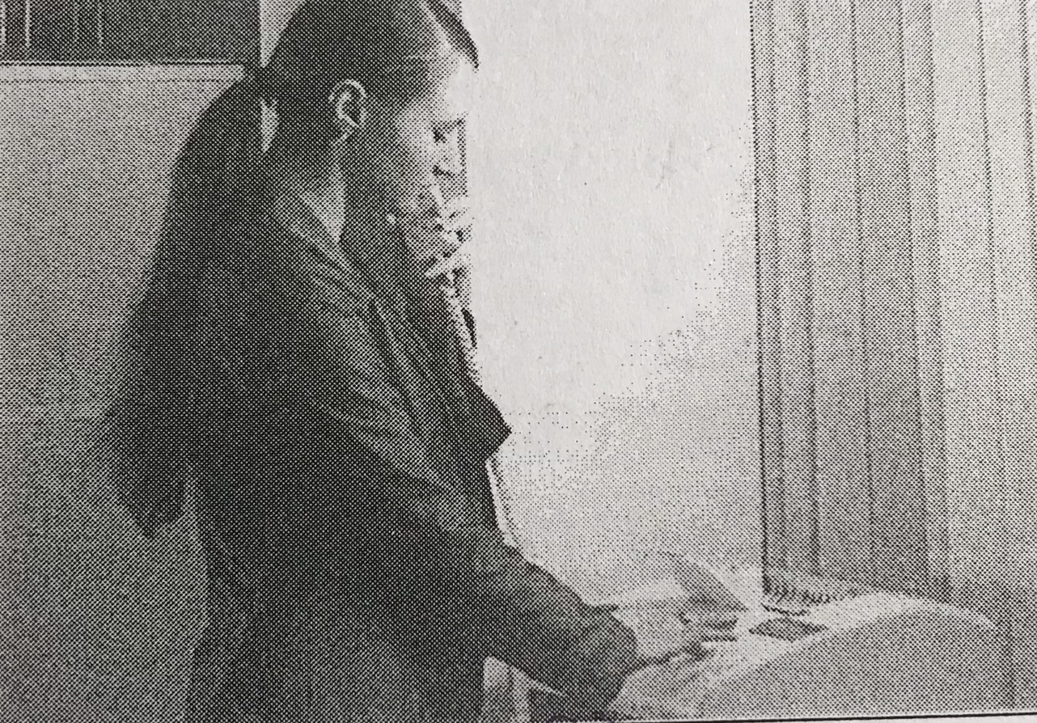

1. A woman is making photo copy
2. A woman is pressing a button
3. A woman is replacing the phoen
4. A woman is reading a documents

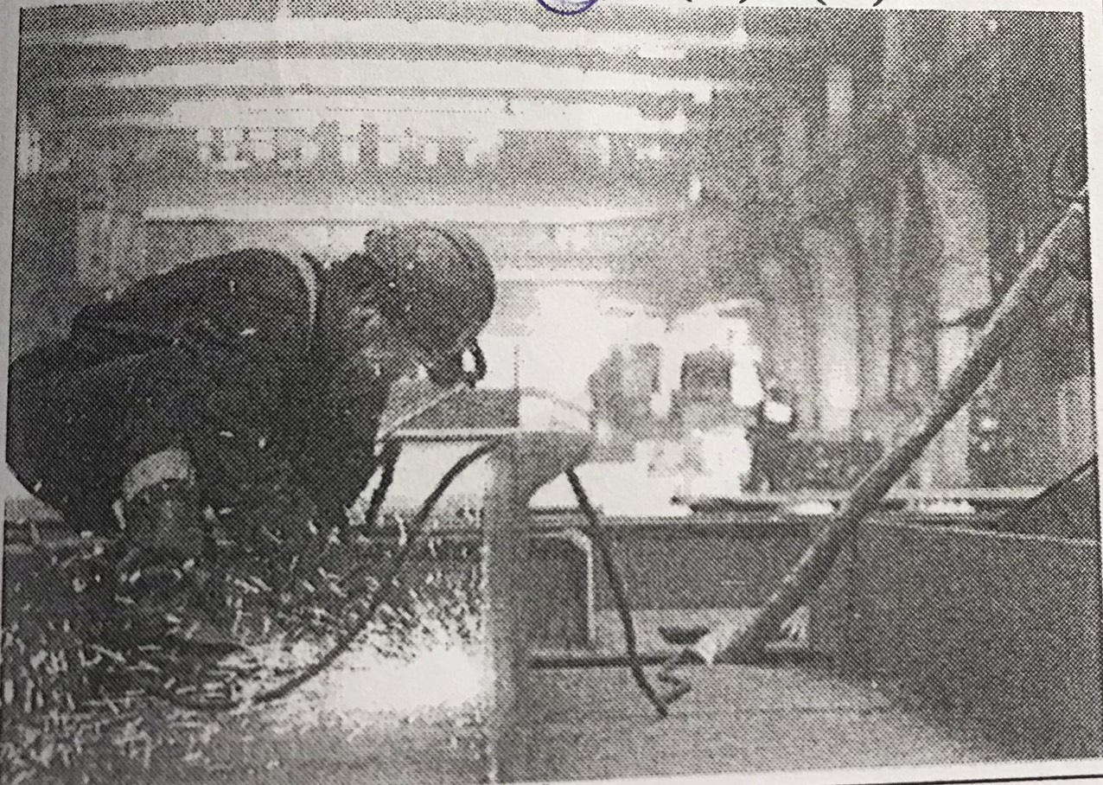

1. The man is changing his clothe
2. The man is welding some metal
3. The man is working in outdoor lab
4. The man is intalling some lights

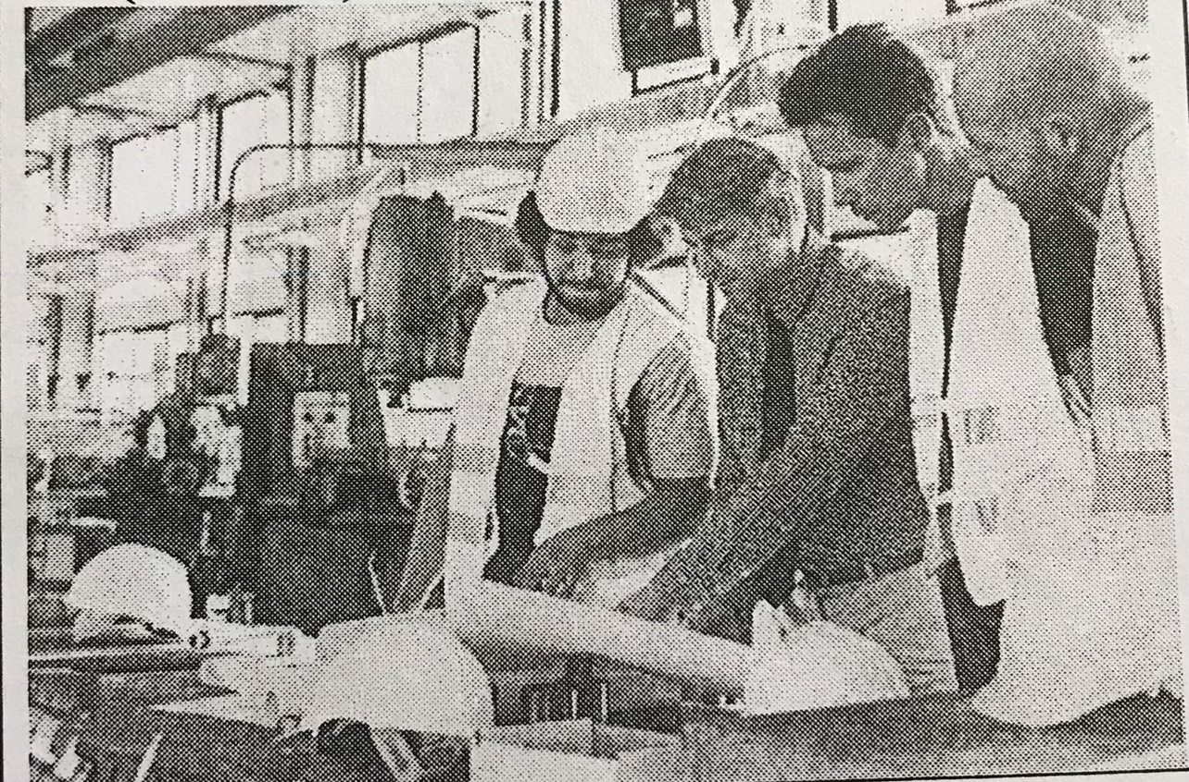

1. All of the man are looking at the blueprint
2. A man is demonstrating of the mechine
3. A man is poiting at the hat
4. One of the man is turning on a mechine

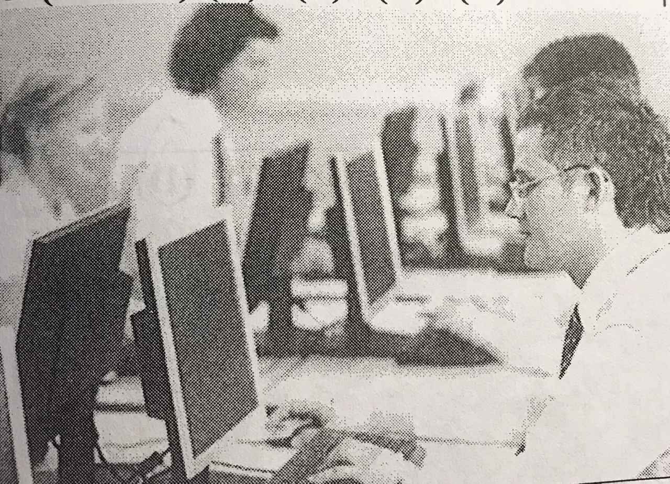

1. All of the computer are being used
2. The people are typing on keyboard
3. Some people are taling to each other
4. Some moniter are being adjusted

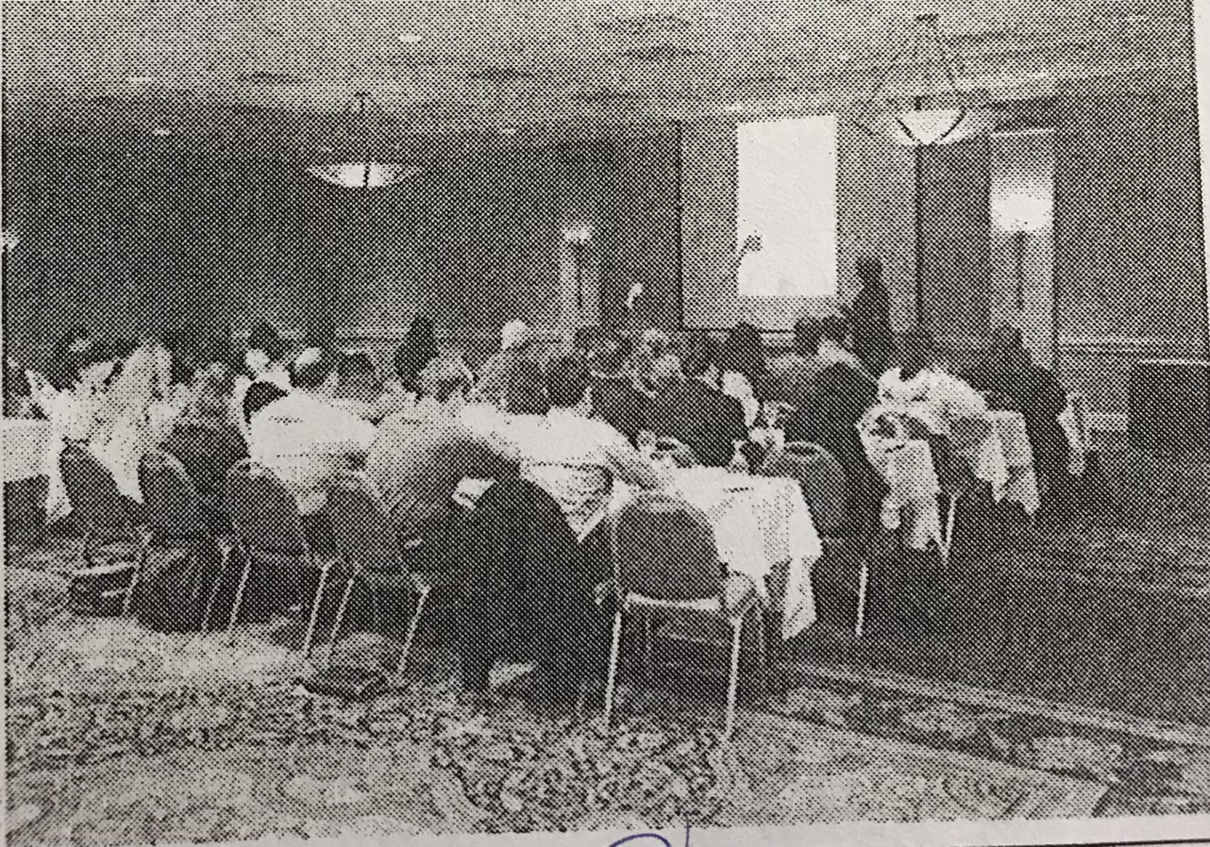

* 1. Some people are listening to a presentation
  2. A white board is being written on
  3. Chairs and table is being set up
  4. Some people are cleaning a light fixture (co dinh)

File 18 – 25

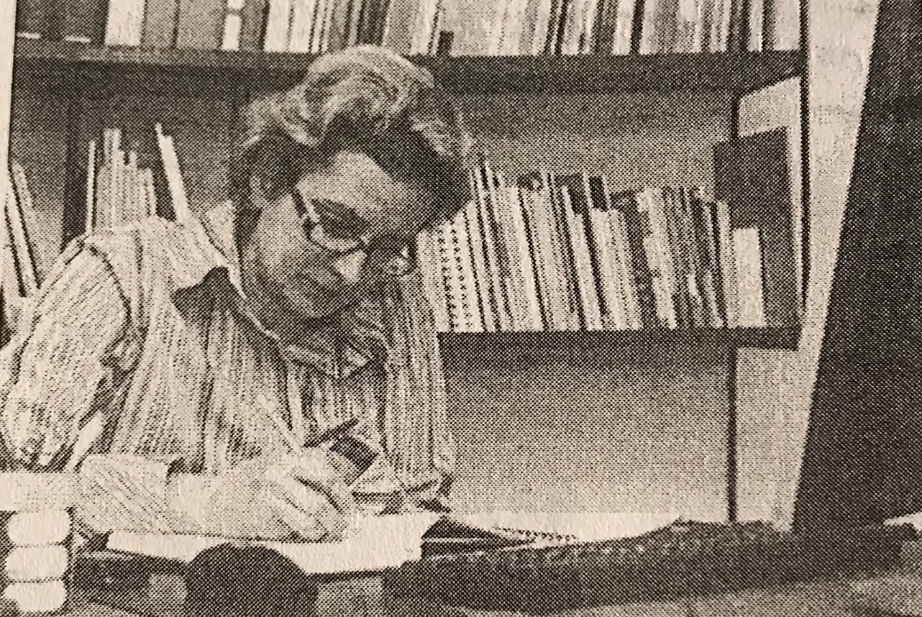

1. The woman is shaperning a pencil
2. The woman is reading a book
3. The woman is writing on a note book
4. The woman is looking at a moniter

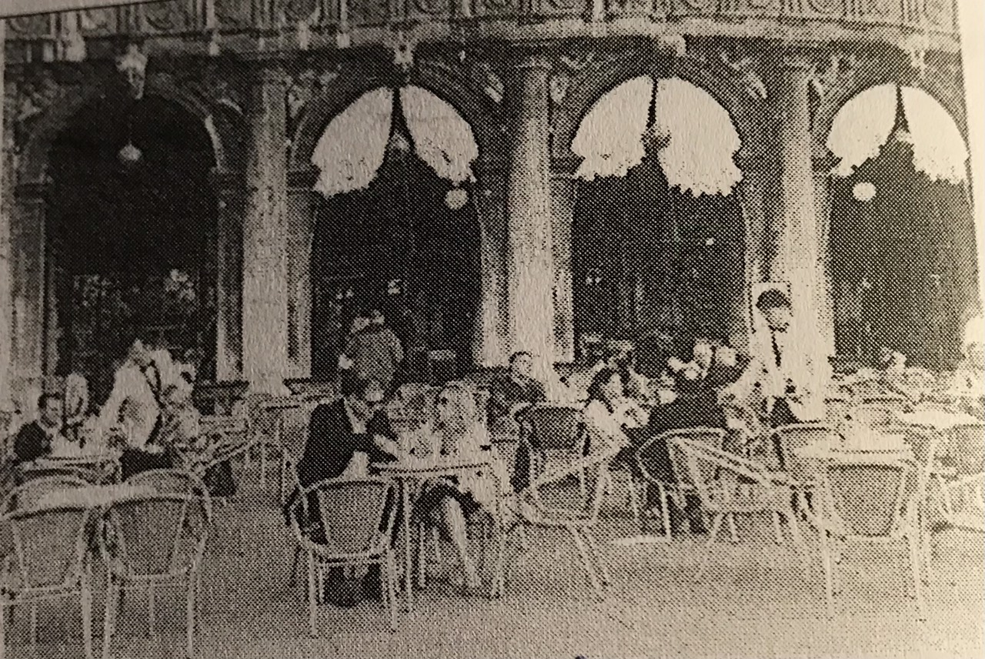

1. Some people are working by
2. Some people are being served
3. A man is hanging some curtains
4. A man is standing on a chair

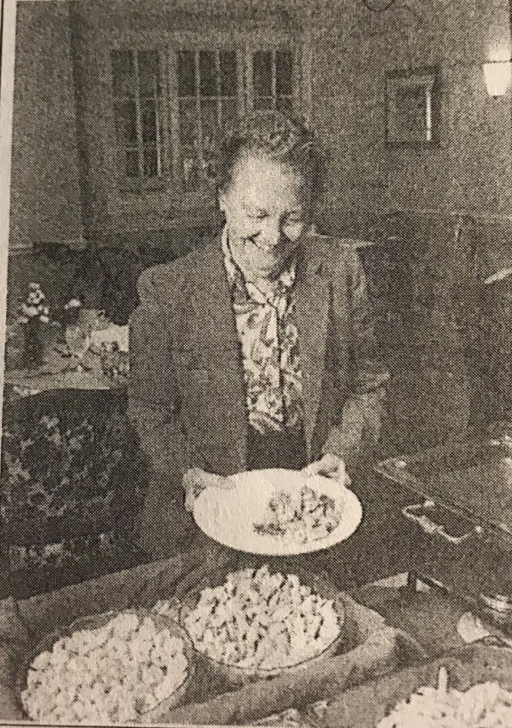

1. The woman is washing some plates
2. The woman is wiping a table top
3. The woman is holding a plate of food
4. The woman is arranging a plate on a table

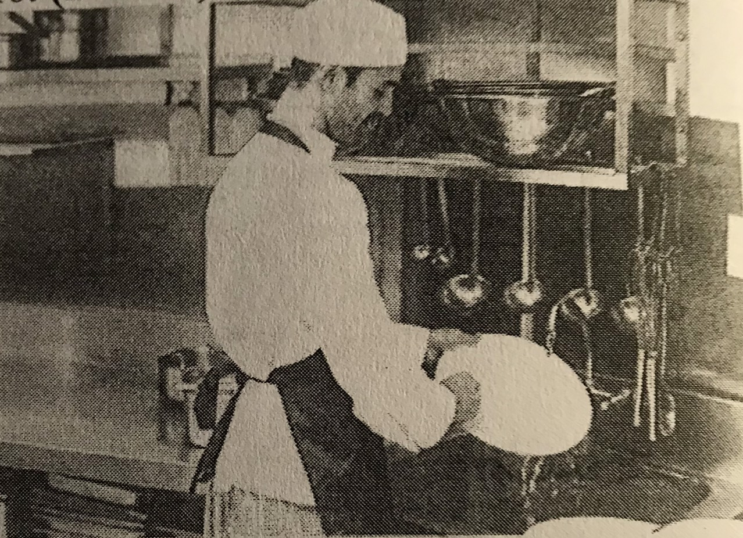

1. The man is stacking some bowl
2. The man is using a ladle ( cai muoi)
3. The man is washing a plate
4. The man is wiping a counter

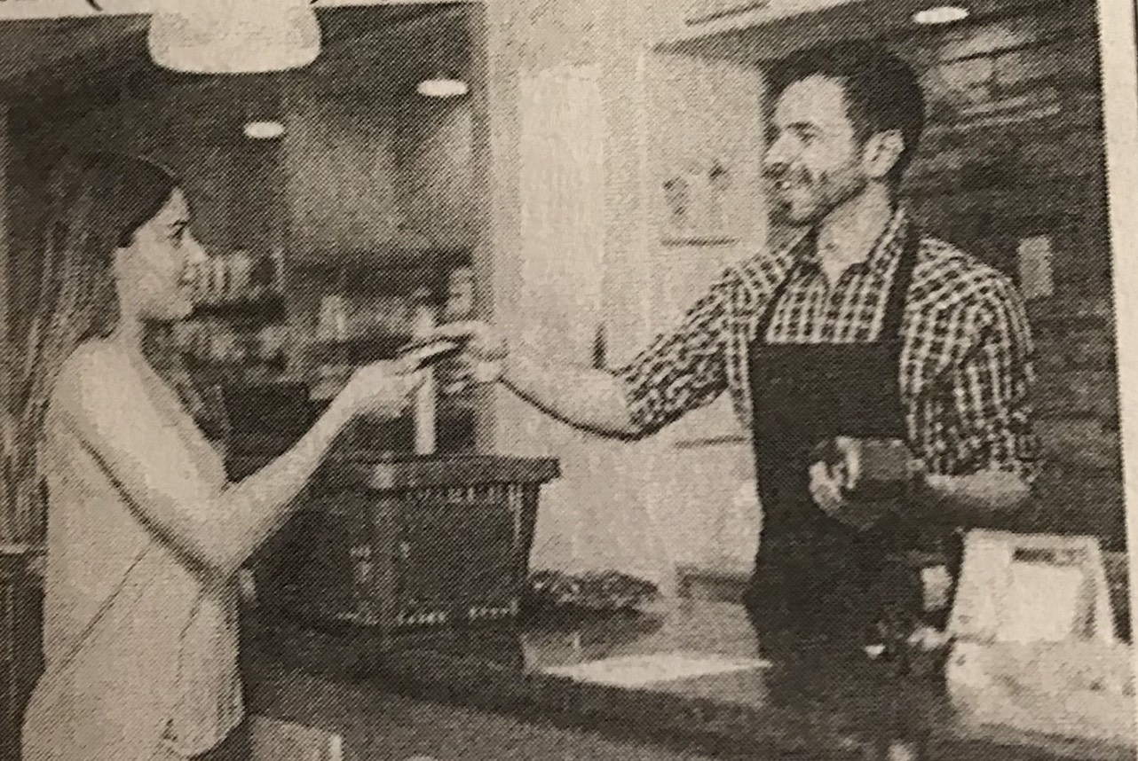

1. She is placing an item into a basket
2. He is removing a basket from a counter
3. She is writing a check
4. He is holding a cardreader

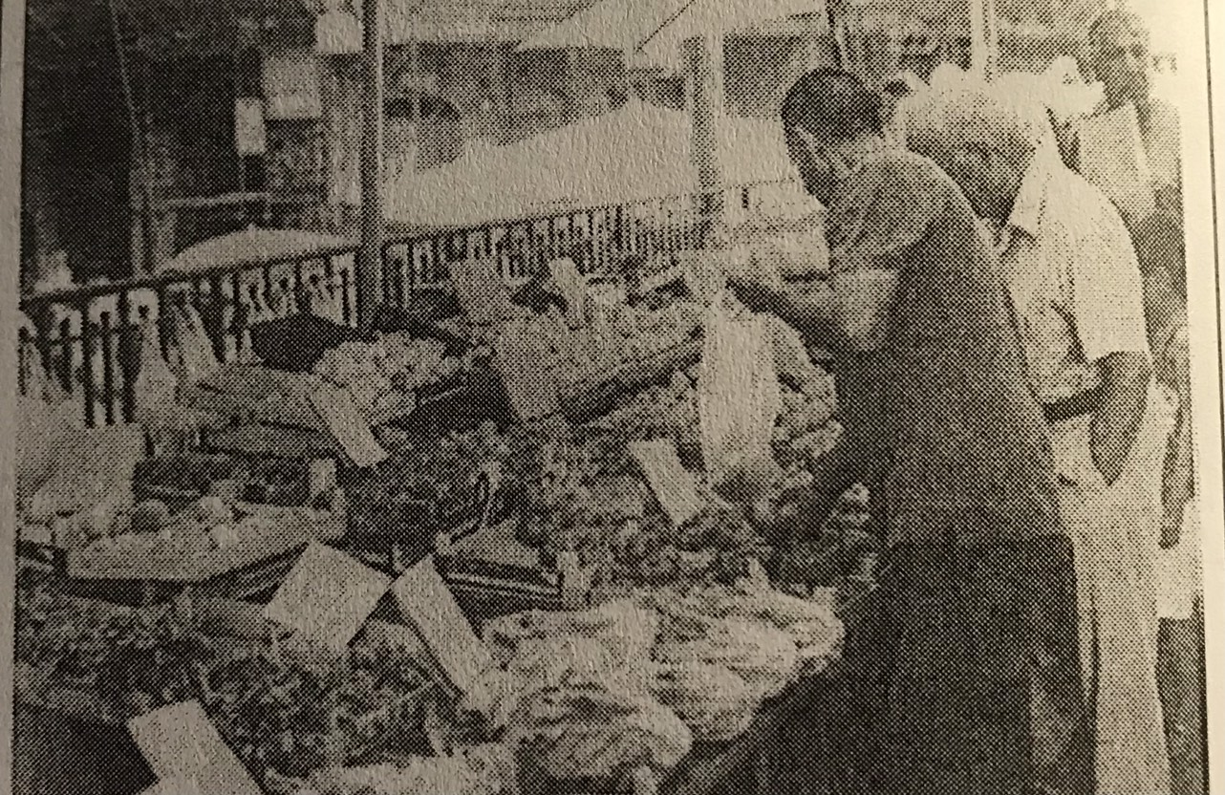

1. One of the man is opening an umbrella
2. One of the man is writing on a signboard
3. One of the man is filling a basket
4. One of the man is holding a plastic bag

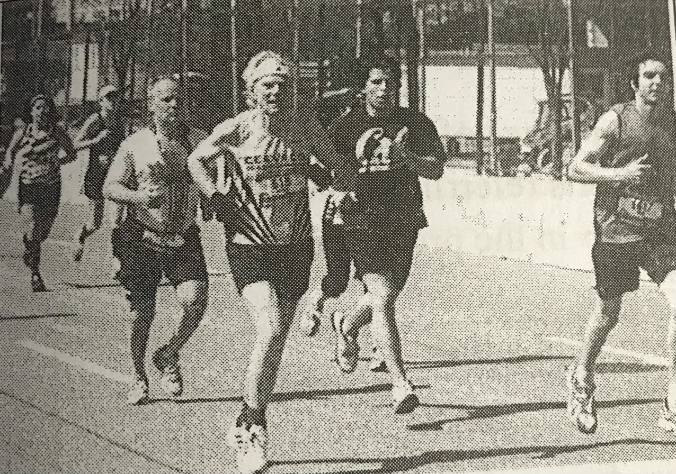

1. People are strolling along the street
2. The runners are wearing long pant
3. People are running down street
4. Some people are holding water bottle

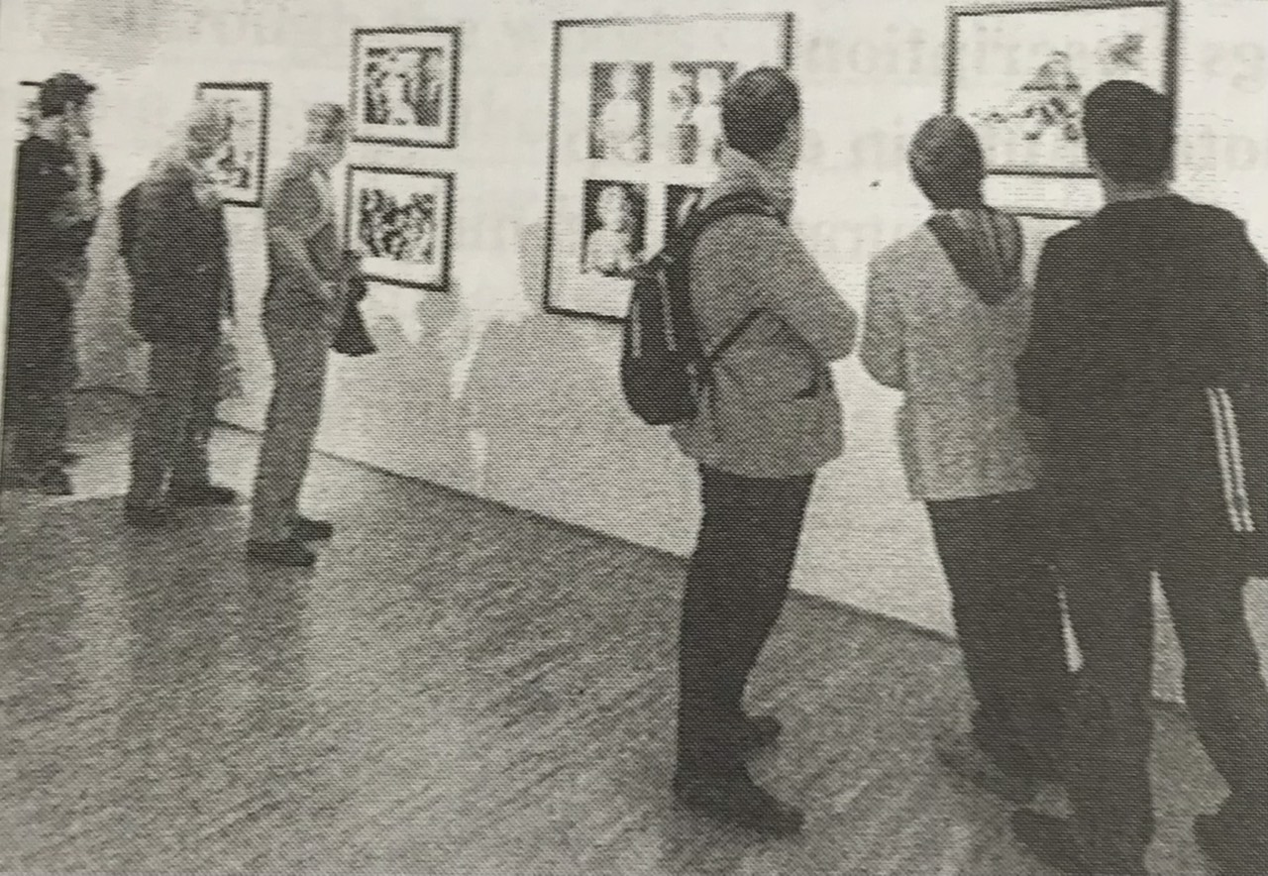

1. Some people are attending an exibit
2. People are leaving the garllery
3. Some people are hanging up photo
4. People are taking some pictuers